**COMSIS: A COMPUTERIZED SALES AND INVENTORY SYSTEM FOR CENTRO MERCADO**

**A Mini Capstone Project**

**Proposal Presented to the**

**Faculty of the**

**Information and Communications Technology Program**

**STI College Caloocan**

**In Partial Fulfilment**

**Of the Requirements for the Degree**

**Bachelor of Science in Information Technology**

**Renan Boniza**

**Jerick Aeron Ching**

**Daisy Janoras**

**Lean Kurt Mallari**

**Jancen Naval**

**Mr. Prax Anzel Donor**

Mini Capstone Adviser

**January 2023**

**EXECUTIVE SUMMARY**

**Title of research:** COMSIS: A Computerized Sales and Inventory System for Centro Mercado

**Researchers:**

Renan Boniza

Jerick Aeron Ching

Daisy Janoras

Lean Kurt Mallari

Jancen Naval

**Degree:** Bachelor of Science in Information Technology

**Date of Completion:** December 2022

**Key words:** Sales, Inventory, Operational System, Store

The Computerized Sales and Inventory System is specifically developed to provide efficient tracking of the stock merchandise and facts, to keep accuracy inside the computation of merchandise and supply safety to their personal and computerized income and stock machine and records may be kept in safe. The Computerized Sales and Inventory System is designed to aid the Centro Mercado in monitoring sales and inventory records. It assists in providing information on the tracking of past and present records. Manual sales and inventory systems are not usually applicable in a convenience store like the Centro Mercado because they give the staff a difficult time computing and monitoring products that the store obtains and acquires, and it also delays the progress. A manual system cannot be completely secure because it is easily tampered with or misplaced by management. The advancement of technology has resulted in significant improvements to the sales and inventory systems.

**Acknowledgement**

This study could not have been completed without the participation and assistance of numerous individuals whose names have yet to be listed. Nevertheless, we would want to convey our gratitude and respect to the following:

To Mr. Prax Donor and Joshua Mendoza, our thesis advisor, for their patience in mentoring us during the conduct of this study. Their insights, remarks, and suggestions were crucial in clearing the path for the accomplishment of this endeavor.

To our cherished STI College Caloocan, for allowing us to create a product that will help society while polishing our academic writing, ability to work under pressure, and teamwork skills.

To our parents and siblings, whose love and support have inspired us from the start. Their affection and support inspired us to persevere rather than give up. Their encouragement kept us going despite the obstacles we encountered.

Our greatest gratitude goes to our Almighty God, the creator of everything, for all the benefits He has bestowed upon us. Without God-given gifts such as wisdom, insight, and creativity, none of this would have been done.

**TABLE OF CONTENTS**

**Page**

**Title Page i**

**Executive Summary ii**

**Acknowledgment iii**

**Table of Contents iv**

**Appendix v**

**List of Figures vi**

**List of Tables vii**

**Introduction 1**

**Project Context 2**

**General and Specific problem 2-3**

**Objectives of the Study 3-4**

**Scope and Limitations of the Study 4 -6**

**Review of Related Literature 7**

**Foreign Literature 7-9**

**Local Literature 9-10**

**Synthesis 11**

**Technical Background:**  12

**Overview of Current Technologies to be**

**Used in the System**

**Methodology, Results and Discussion 15**

1. Requirements Analysis

Research method 15

Phase I: Requirements/Plan 16

Phase II: Design 16

Phase III: Development and Coding 16

Phase IV: Integration and Testing 17

Phase V: Implementation and Demonstration 17

Phase VI: Review 17

1. Requirements Documentation/Finish System 17

Wireframe 18-22

HIPO Chart 26

Data Flow Diagram 27-28

**Appendix 28**

**Appendix A: Reference 28**

**Appendix B: Wireframe 28**

**Appendix C: Personal Technical Vitae 33-37**

|  |  |  |  |  |
| --- | --- | --- | --- | --- |
| FIGURE NAME |  |  | **PAGE** | |
| **Figure 1: Agile Methodology** |  |  |  | **16** |
| **Figure 2: Login Module** |  |  |  | **18** |
| **Figure 3: Admin Home Module** |  |  |  | **19** |
| **Figure 4: Admin Sales Module** |  |  |  | **19** |
| **Figure 5: Admin Transaction Module** |  |  |  | **20** |
| **Figure 6: Admin Inventory Module** |  |  |  | **20** |
| **Figure 7: Admin Account Information**  **Module** |  |  |  | **21** |
| **Figure 8: Staff Stock-In Module** |  |  |  | **21** |
| **Figure 9: Staff Stock-Out Module** |  |  |  | **22** |
| **Figure 10: Staff Transaction Module** |  |  |  | **22** |

**LIST OF FIGURES**

|  |  |
| --- | --- |
| **LIST OF TABLES** |  |
| **TABLE NAME** | **PAGE** |
| **Table 1: Data Dictionary: Users Dictionary** | **23** |
| **Table 2: Data Dictionary: Items List** | **24** |

**Table 3: Data Dictionary: Out of stock List 24**

**Table 4: Data Dictionary: Stock-In Amount 24**

**Table 5: Data Dictionary: Stock-In Product 25**

**Table 6: Data Dictionary: Trash Bin 25**

**CHAPTER I**

**INTRODUCTION**

Some businesses are heavily invested in computerized technology in order to increase output and become more competitive in the business world. A computerized sales and inventory system greatly assist in making the work more productive and progressive, as well as providing an easier way of doing product sales and inventory. A sales and inventory system are a desktop-based business solution that tracks both sales activity and inventory at the same time. Manufacturers and trade resellers can both benefit from a comprehensive solution in which a single transaction entry records customer, product purchased, price, and date while also updating inventory levels.

Today's technological advancements provide users with efficiency and dependability, as well as the simplest method of managing and monitoring transactions. These changes have a significant impact on society by making work easier. Managing a large company is difficult because it requires a great deal of responsibility to keep the processes running smoothly. A computerized sales and inventory system allow the company to easily access sales and inventory records, which saves time during the transaction process and allows them to track down the products that the company obtains and acquires.

**Project Context:**

The researchers are carrying out the proposed study, COMSIS: Computerized Sales and Inventory System for Centro Mercado. Nowadays many shops or stores are more about using a computer to make an inventory. The information concerning the store's products is always in computerized operation which is properly organized and managed but no more informative. All inventories are recorded in a book, but other transactions are not handled properly. Computerized inventory is important in retail stores, particularly those where there is a large number or variety of commodities or items for sale. Distributors, wholesalers, retailers, and manufacturers are having a hard time managing their stocks. The lack of effective inventory would make it extremely difficult to track available inventory to meet demand. In the book record, all the important items are stated, but unlike the computerized system, even the smallest details are recorded that can avoid difficulties in the future transactions.

**General Problem:**

**How to develop a “COMSIS: A Computerized Sales and Inventory System for Centro Mercado”?**

The Centro Mercado store had a problem managing their business in terms of product inventory and sales monitoring. In addition, they continue to use paper-based or manual computation and inventorying of their products.

**Specific Problems:**

1. **How to develop a module that can monitor the sales records?**

Centro Mercado uses a manual-based monitoring of income such as manual computation of sales.

1. **How to develop a module that can monitor the inventory of products?**

Centro Mercado staffs continue to manually inventory items or products. It can consume time and hassle, and it can lead to inventory mismanagement.

1. **How to develop a module that can restore important files?**

Centro Mercado struggles when it comes to losing important data/files.

**Objectives of the Study:**

The objective of this project is to develop a system that can handle and manage the activities involved in Centro Mercado in an efficient dependable manner. Create and implement a computerized sale and inventory system that will improve the operation of the Centro Mercado. COMSIS: A Computerized Sales and Inventory System is designed to address a problem with the current manual system. It is intended to computerize the Centro Mercado's sales and inventory. This will reduce the difficulty and time required, particularly mismanagement.

**General Objectives:**

**Develop a “COMSIS: A Computerized Sales and Inventory System for Centro Mercado”**

For the benefit of the Centro Mercado store, the researchers aimed to develop a Computerized Sales and Inventory System that helps them in terms of functionality without mismanagement.

**Specific Objectives:**

1. To develop and implement a generated module that will monitor the sale reports/records.

The proposed system develops a module that will handle the record and important data such as sales reports of the Centro Mercado.

1. To develop and implement a module that will monitor the inventory of items or products.

The proposed system develops a module that can monitor all the items available in Centro Mercado, items that low of stock will notify the admin.

1. To develop and implement a file maintenance module that will handle the files, record, and important data.

The proposed system develops a module that will provide maintenance if Centro Mercado lose important files or become corrupted.

**Scope and Limitations of the Study:**

**Scope:**

**User**

The target users for this system are the Owner and Centro Mercado’s staff.

**Staff**

The staff of Centro Mercado has a privilege to view the records of inventory and sales reports.

**Owner/Administrator**

The admin of the store has the authority to view, insert, update, and delete records, including the daily records of the store, to monitor the business's performance.

**Modules:**

Some modules of COMSIS: A Computerized Sales and Inventory System are:

**Login Module**

This module allows users to log-in on the system by entering a valid username and password.

**Home Module**

This allows admin/owners and staff to see the dashboard containing sales and inventory reports.

**Transaction Module**

This module allows the admin to view, insert, update, and delete transaction record.

**Inventory Module**

This module allows the admin to view the inventory of the items/products, monitored and manage the stocks of their products.

**Sales Information Module**

This module allows the admin/owner to create sales.

**Account Information Module**

This module allows the admin/owner to create and view the list of the person who has access to the system, as well as grant users accounts.

**Recycle Bin Module**

This module allows the admin/owner and staff to recover the deleted or corrupted file/data.

**Stock-In Module**

This module allows the staff to add and input new items or products.

**Stock-Out Module**

This module allows the staff to deduct the stock list of the sale items.

**Limitations:**

* **The system is exclusively to the owner and authorized personnel only.**

The info in this system is not able to share and does not access any person who’s not in charge in the system.

* The system does not include payroll operation as well as receipt.

The payroll operation and receipt does not cover in this system. This system is for sales and inventory of items only.

* Online ordering does not cover by the system.

COMSIS does not deal with any online/Wi-Fi connection used to transact.

**CHAPTER II**

**REVIEW OF RELATED LITERATURE/SYSTEMS**

**Review of Related Literature:**

This chapter provides background information by discussing some related studies. Furthermore, it attempts to identify the knowledge gap in the use of Computerized Sales and Inventory System.

**Foreign Literature:**

# **Types of Sales and Inventory**

According to Janes (2019), computers are extremely dependable devices and very powerful calculators with some great accessories’ application such as processing problem for business activities, regardless of size, computers have three advantages over other types of business equipment that process information because computers are faster, more accurate, and more economical. The system gathers data to help with production scheduling. Some systems, for example, use recent sales data to forecast how many of a particular type of product will be required to meet consumer demand soon. The monitoring includes product levels at all locations.

The system compares current product inventory levels and scheduled production numbers to the amount needed and determines whether the level of production must be changed or not. If a change is required, the system sends a message to the master production scheduler to increase production. Furthermore, if product retail sales do not meet the company's sales targets, the system slows production.

# **Inventory Management System**

The difference between a manual and a computerized system, according to Shanker (2018), is speed. The processed data can help to reduce errors and increase efficiency. The data entered can be easily summarized in a matter of seconds.

While manual computing with paper and pencil or ball pen is less expensive than a computerized sales system, which necessitates the purchase of a machine and system software. Training and program maintenance are two other costs associated with computer processes.

According to Aberdeen Group (2017), this year, companies are prioritizing supply visibility, inventory optimization and supply chain analytics, and supply chain outsourcing as ways to reduce Supply Chain Management (SCM) costs.

**Inventory System**

The United States Inventory, according to the Small Business Administration (2010), refers to stocks of anything needed to do the job. The United States Small Business Administration defines successful inventory management as balancing the cost benefits of inventory, which includes maintaining a wide collection without spreading the rapidly moving items too thin, increasing inventory without sacrificing service, keeping stock low without sacrificing performance, obtaining a lower price by purchasing volume, and maintaining an adequate inventory without an excess of obsolete items.

According to Jonas Claymore's (2015) work, the cost-effective and highly innovative inventory management system provides instant access to stock levels, allows for timely orders, and eliminates time waste. Get real-time reports.

The inventory system allows you to buy supplies based on the most recent order data record. This reduces overstocking while also freeing up resources for more pressing needs. The Inventory Ordering System gives you better control over your supply chain by allowing you to place orders online or via SMS.

Furthermore, because the systems generate inventory and sales reports automatically, your employees will have less paperwork to file and more time to focus on operations. This user-friendly inventory management system can be customized for any multi-site such as company, commissary, or warehouse backend for exceptional businesses with franchise activities.

**Local Literature:**

**Sales and Inventory System**

In accordance with the study of De Alday Espino Ragudo (2016), Computerized Sales and Inventory system for Ramon Trading. The proposed system replaced the manual system, resulting in more efficient and accurate transaction processing. The system is dependable, eliminates errors and inaccurate information, and generates valuable, accurate reports.

According to Navarro (2015), Sales and Inventory System, a computer is a general-purpose device that can be programmed to perform finite set arithmetic or local operations. Because of technology, computers play an important role in our society today. Wherever you go, there is a computer, and especially in business, it simplifies and sources the procedure by converting the manual system into a computerized system.

**Sales and Inventory Monitoring System**

According to Bianca, Demand Media (2018), using this type of system, a company makes strategic business decisions regarding raw materials purchased, production scheduling pricing, and other supply decisions. Sales and Inventory data enables the company to increase or decreases of products in the factory so that the company does not have too many finished goods stored in its warehouse.

A sales and inventory monitoring system gather data to help with production scheduling. Some systems, for example, use recent sales data to forecast how many of a particular type of product will be required to meet consumer demand soon. This includes keeping track of product levels in all locations. A good example is a multinational corporation with customers all over the world. Although the customer may reside in Japan, the system must monitor whether the warehouse in Canada has available product to ship to Japan. Other people used computers daily. Some people use it for transactions, while others use it for education and data storage.

Though it may appear unnecessary, storing files and so on. The use of computers simplifies the process of storing and managing files for future use, as well as making finding files easier than the manual process. Because the Computerized Sales and Inventory System is a product of human knowledge combined with the use of technology, why not take advantage of it?

This proposed system aims to reduce work and solve problems involving strict and complex recording and calculations. A sales and inventory system are important in planning a small or large business transaction, as well as for businesses that do not want to go bankrupt or lose profits.

As a result, several studies were conducted to develop a more reliable system and to assist businesspeople in making their business transaction processing easier and faster, thereby providing more convenience and satisfaction to the business.

**Synthesis:**

This paper works has different aspects such as implementing a system that more valuable for a shop. Today, computer-based paper is widely used for its efficiency and precision. It helps to carry out the task in a simple way with less time consumed. This enables the shops to be more competitive. In business like merchandise, sales and inventory system plays a significant role. It is used to track all transactions completed by the company and responsible for monitoring supplies. All store operations must be properly recorded and must be fully password protected. A computer system is the best solution and the most innovative response for their requirements. The sales and inventory system that are done manually actually takes a lot of time and effort. And the use of a computerized system as a method of implementing computer technology would make it more advantageous. So, because of this literature study, researcher appreciate the work of other researchers which includes all the important matter that connects with the COMSIS study.

**TECHNICAL BACKGROUND:**

**Overview of Current Technologies to be used in the System:**

The research enumerated the following areas, program, and application to use for the proposed system to have an effective management and flow of the study.

The researchers will use Microsoft Visual Studio as a text editor to write the codes and create this project. Furthermore, the researchers will employ XAMPP as a local host database for storing all raw data entered during the programming stage. The researchers intend to use technology like:

C#

C# (pronounced "C-sharp") is a Microsoft object-oriented programming language that aims to combine the computing power of C++ with the programming simplicity of Visual Basic. C# is based on C++ and includes features like Java.

C# is intended to be used with Microsoft's.NET platform. Microsoft's goal is to make it easier to exchange information and services over the Internet, as well as to enable developers to create highly portable applications. C# simplifies programming by utilizing Extensible Markup Language (XML) and Simple Object Access Protocol (SOAP), which enable access to a programming object or method without the programmer having to write additional code for each step. C# is expected to grow in popularity because programmers can build on existing code rather than repeatedly duplicating it.

**Resources:**

This chapter illustrates the minimum and recommended system requirements namely hardware requirements, and software requirements.

**Hardware Requirements**

These requirements include the minimum CPU speed, memory and disk space needed to install windows. In most cases, you will want to ensure that your hardware exceeds these requirements to provide adequate performance for server-based services and applications.

|  |  |
| --- | --- |
| **Hardware** | **Requirements** |
| Processor | Intel® Core™ i5-8265U CPU @ 1.60GHz 1.80GHz |
| Memory | 8 GB RAM |
| Device ID | 3B81DAF9-7982-47DA-8547-F9BF4541AF63 |
| Product ID | 00327-30708-45303-AAOEM |
| System type | 64-bit operating system, x64-based processor |
| Keyboard | Standard Keyboard |
| Mouse | Optical Mouse |
| Audio | Sound Card |

**Software Requirements**

This is a document that describes what the program will do and how it should work. It also outlines the functionality the product needs to satisfy all user needs.

|  |  |
| --- | --- |
| **Software** | **Requirements** |
| Operating System | Microsoft Windows 8 64-bit |
| DirectX | Version 11 |
| Software Framework | .NET Framework 4.5.1 |
| Microsoft Visual Studio | 2015 Version 14.0 |
| Unity | Version 5.0 |
| MySQL | Latest Version |

**CHAPTER III**

**METHODOLOGY, RESULTS, AND DISCUSSION**

This chapter presents the development of COMSIS: A Computerized Sales and Inventory System for Centro Mercado. All the processes in developing this research paper are shown in this chapter such as the project development wherein the programming paradigm used in the system is object-oriented programming. The project development started once the project was approved. The graphical user interface was first done for the program flow and the database was then created afterwards. After it the functionality and the processes of the system were developed. The generation of the reports was the last module that was developed. The codes were constantly debugged and there were risks that the group encountered. The hardware and the software requirements were met so there were no problems regarding it and then the incremental model was implemented in the development system.

**A. Requirement Analysis**

**Research methods**

Agile Methodology diagram shows how the research and process is developed from the beginning to the end of the process. Agile methodology is simple to use as a methodology model because, as you can see from the diagram, it was processed step by step so that any problems that may arise can be polished or refined. Agile methodology is the most efficient and adaptable method for the system. It makes it easier to incorporate changes within the development process and can quickly give the client something to see and use to provide feedback on the system's use. The advantage of the Agile methodology model over other methodologies is that it reduced development time, encouraged the client to provide feedback on the prototype system, and the integration done from the start solved many integration issues.

The methodology chart for the study.

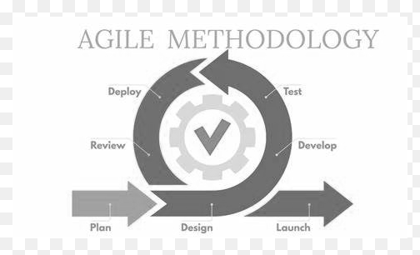

*Figure 1 Rapid Application Development Methodology*

**Phase I: Requirements/Plan**

The researcher's goal in this phase is to get to the first step of the Centro Mercado's first cycle. Proponents believed that a proposal to create a solution to the problem in Centro Mercado was in the works. The proposed system will aid in the creation of services and improve their work performance, making inventory of products and monitoring sales records easier.

**Phase II: Design**

The system design is the development that corresponds to the environment of the Centro Mercado to have a simple system. The proposed system will be a significant change for the organization. All sales transactions and inventory records will be computerized. It will be much easier to access with the new system because the database of the system holds all sales and inventory records, and it has a user-friendly interface for customizing data.

**Phase III: Development and Coding**

During the system development, the researchers collect information and suggestions for the Centro Mercado study. After collecting information and suggestions for Centro Mercado study the developers started to develop the system.

**Phase IV: Integration and Testing**

Testing is where the system is used by project respondents to see if it is reliable, efficient, and effective in terms of its uses, more advanced than their manual system. The testing of the proposed system is important because the store will see if the system is completely effective and can make the respondents' work easier and faster.

**Phase V: Implementation and Demonstration**

After the testing of the proposed system, implementation of the system follows, during this phase the new or the created system will be installed in the production process, the users will be trained or will be guided on how the system works. The system will be handed over to the client, and the processes will be assessed. Effort is also required in this phase to be implemented, resolving identified problems, and planning for system sustainability.

**Phase VI: Review**

After the admin examined the system, they give their side comments about the system wherein this will help if there is anything else that needs to be fixed or added.

**B. Requirements Documentation/Finish System**

This section depicts the agreement between the client/customers and the developers/programmers on the structure of the structure product. It also has software features.

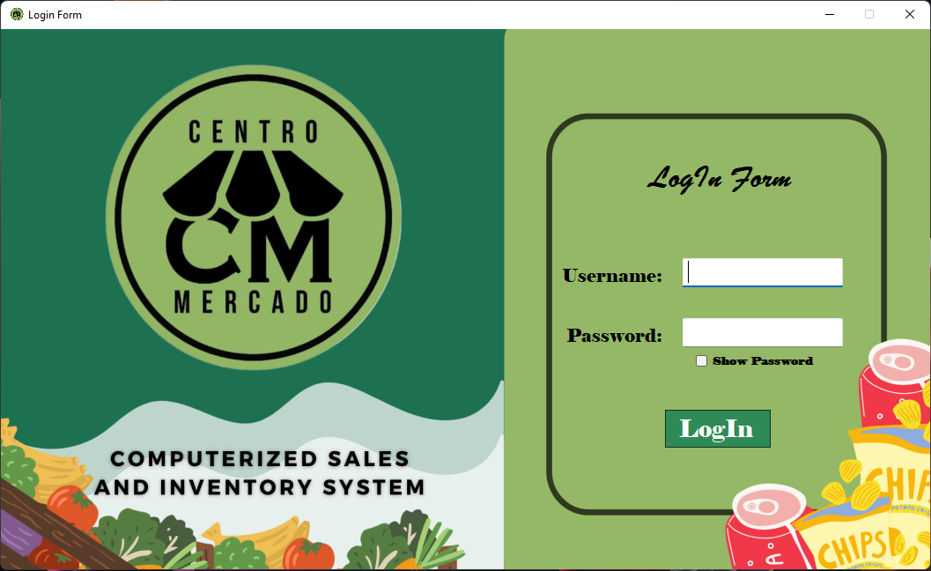**Wire Frame**

*Figure 2 Login Module*

This page will give the user access to their account so they can manage and track their transactions, inventory records as well as other information about the Centro Mercado Store.

**ADMIN MODULES:**

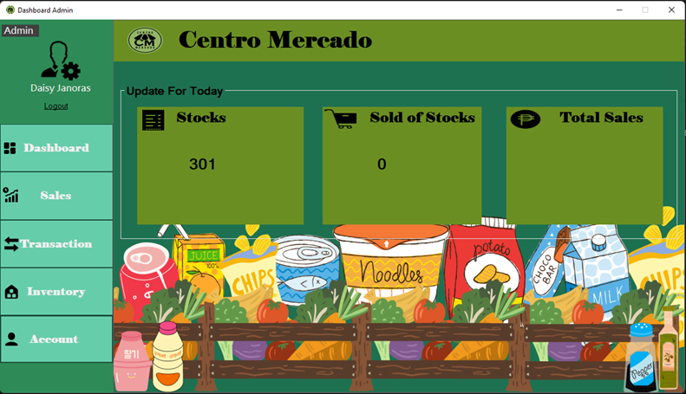

*Figure 3 Admin Dashboard/ Home Module*

This is the home page of the system and have a previous record view for the admin on the stocks, sold stocks and total sales update.

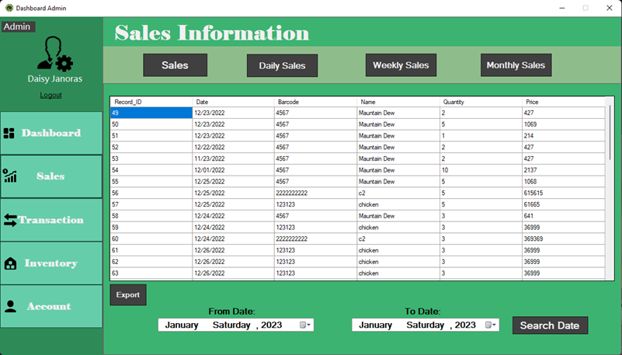

*Figure 4 Admin Sales Information*

This is the home where the admin can customize the date on which the admin will view the sales record.

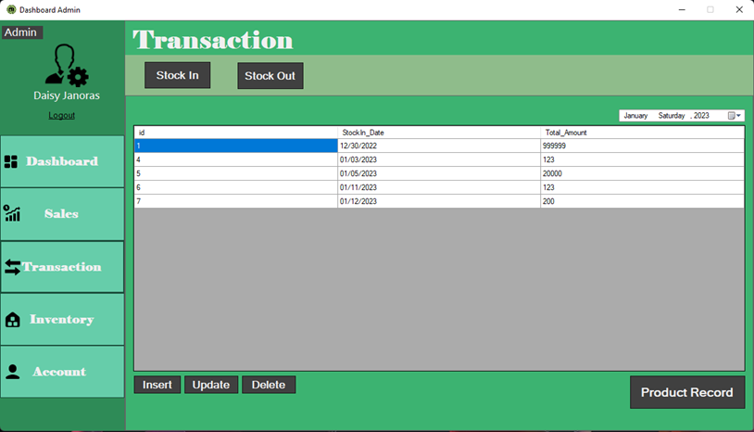

*Figure 5 Admin Transaction Module*

This module is where the admin can view the product record and insert, update, and delete transaction records.

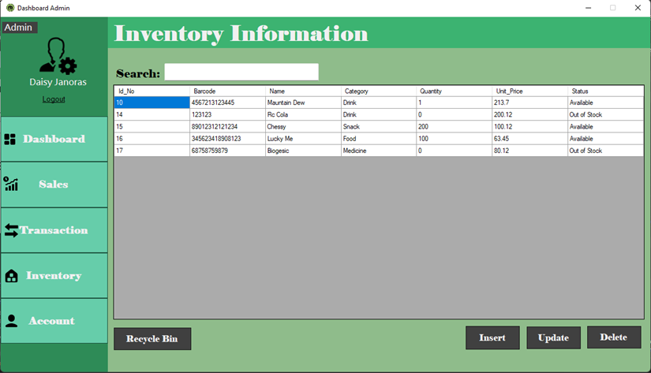

*Figure 6 Admin Inventory Information Module*

This module allows the admin to monitor inventory records and insert, update, and delete inventory records. This module also includes a recycle bin where the administrator can restore data if the admin deletes it by mistake.

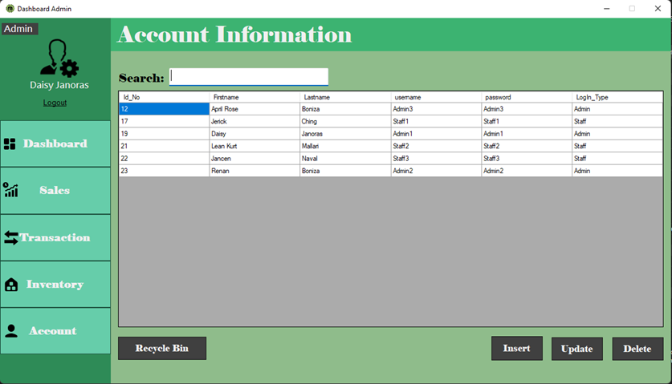

*Figure 7 Admin Account Information*

This module is where the admin can create account for the staffs for them to have access in the system.

**STAFF MODULE:**

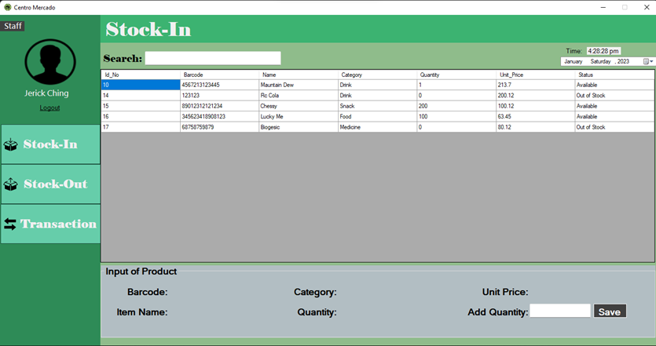

*Figure 8 Staff Stock-In Module*

This is Stock-In module where the staff inputs the new product/item for inventory records.

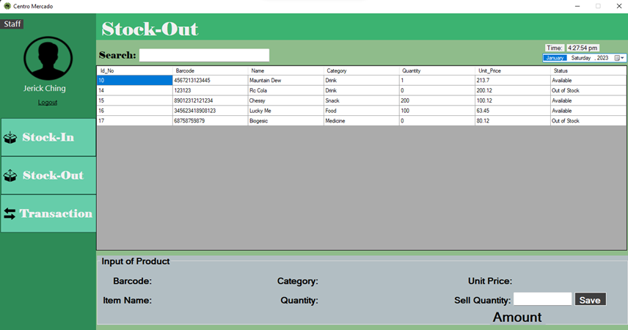

*Figure 9 Stock-Out Module*

This is the module where the staff enters the already sold products or items.

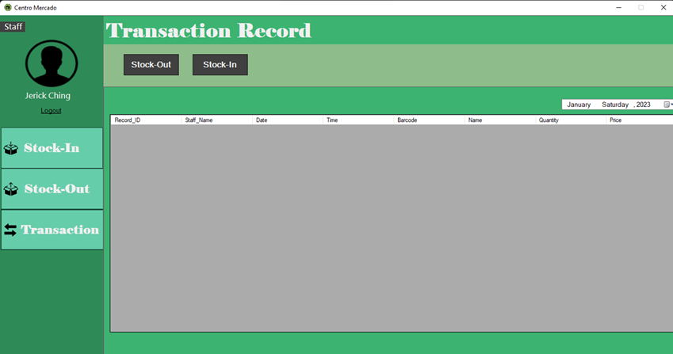

*Figure 10 Staff Transaction Record*

This module is where the staff can view the transaction records created by the admin.

**C. Development and Testing**

When developing a system, you must adhere to certain procedures to ensure that nothing is overlooked and that the result is satisfactory. During the development stage of COMSIS, the researchers easily found a client close to one of the researchers. Following the planning on how they will develop the system, they consulted and surveyed some Centro Mercado staff on what problems they had encountered using the store's manual-based process, so that the proponents could know what requirements they would require in developing the system. A system must be user friendly for all users to read and understand what is in the system. Developing a system is a trial-and-error process, which is why we must test it before implementing it.

**D. Description of Prototype**

**DATA DICTIONARY**

Inventory Accounts



*Table 1: Users Dictionary*

This table consist of the basic information of the user as well as their username and password of the system.

**Inventory Items**



*Table 2: Items List Dictionary*

This table consist of list of products and items and its prices.



*Table 3: Out of Stock List Dictionary*

This table consist of list of out-of-stock items or products.



*Table 4: Stock-In Amount Dictionary*

This table contains how much it is spent on buying new products.



*Table 5: Stock-In Product Dictionary*

This table consist of new items, price, and quantity.



*Table 6: Trash Bin Dictionary*

This table consist of the list of the deleted data.

**HIPO Chart**

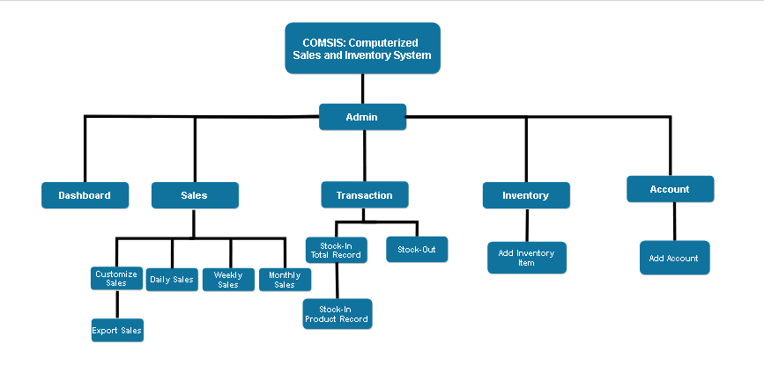

*Figure 11: Admin Account*

This figure shows the inputs and outputs processes of an admin account.

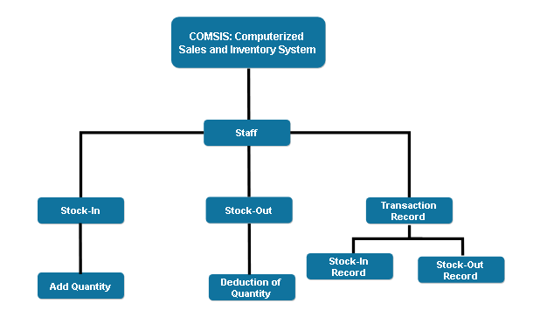

*Figure 12: Staff Account*

This figure shows the inputs and outputs processes of a Staff account.

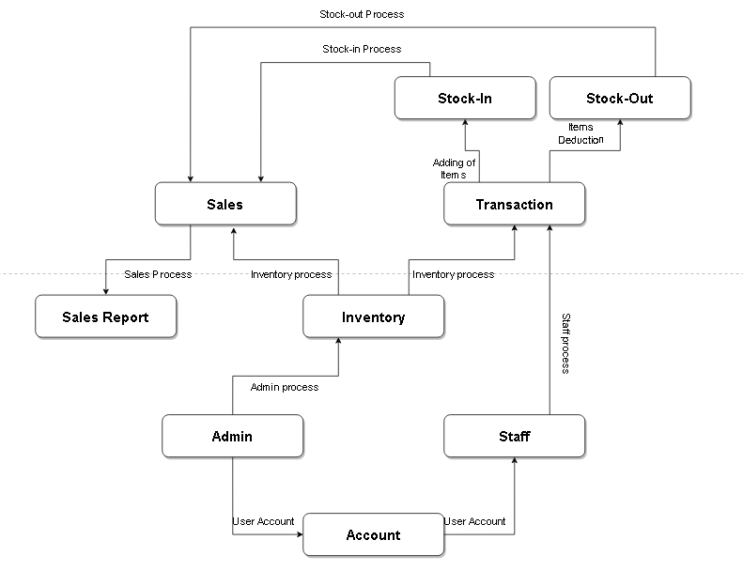**Data Flow Diagram (DFD)**

*Figure 13: Existing Context Diagram*

This figure shows the existing manual process of the Centro Mercado store.

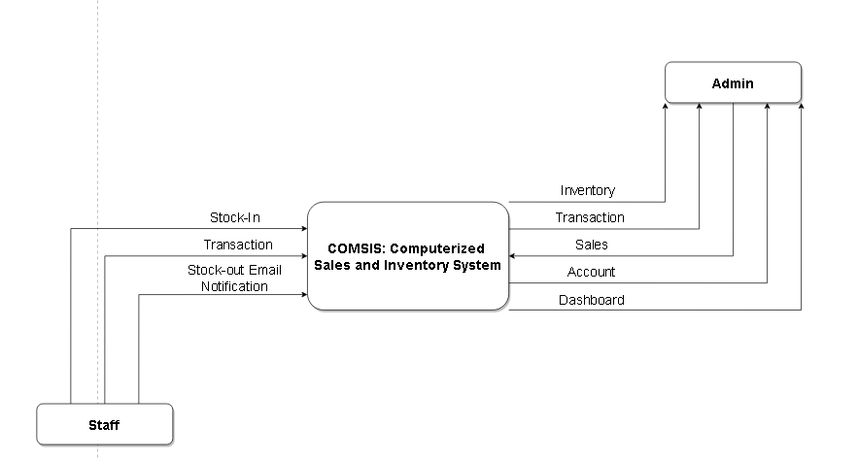

*Figure 14: Proposed Context Diagram*

This figure shows the Proposed Context Diagram of the proposed system.

**Appendix:**

The researchers' references, resource person(s), and curriculum vitae are listed on the following pages. Those who contributed to the development of the research are referred to as resource persons.

**Appendix A: References**

Tim Crosby(2007) , How Inventory Management Systems WorkRetrieved 22,Jun 2013 from <http://money.howstuffworks.com/how-inventory-managementsystems-work1.htm>

Tim Zierden (2009), 4 Keys to Inventory Managemen,t Retrieved on 27 July 2013 from <http://www.fi-magazine.com/channel/certificationtraining/article/story/2009/05/4-keys-to-inventory-management.aspx?prestitial=1>

Zipkin, P.H., 2000. Foundations of Inventory Management, McGraw-Hill, New York.

<http://www.studymode.com/essays/Sale-Inventory-System-1117762.html>

<http://www.studymode.com/course-notes/Inventory-System-1128684.html>

**Appendix B: Wireframe**

**PROPOSED LAYOUT**

**Wire Frame**

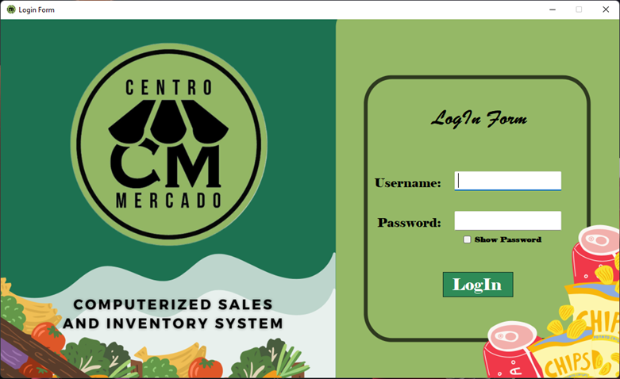

*Figure 2 Login Module*

This page will give the user access to their account so they can manage and track their transactions, inventory records as well as other information about the Centro Mercado Store.

**ADMIN MODULES:**

*Figure 3 Admin Dashboard/ Home Module*

This is the home page of the system and have a previous record view for the admin on the stocks, sold stocks and total sales update.

*Figure 4 Admin Sales Information*

This is the home where the admin can customize the date on which the admin will view the sales record.

*Figure 5 Admin Transaction Module*

This module is where the admin can view the product record and insert, update, and delete transaction records.

*Figure 6 Admin Inventory Information Module*

This module allows the admin to monitor inventory records and insert, update, and delete inventory records. This module also includes a recycle bin where the administrator can restore data if the admin deletes it by mistake.

**

*Figure 7 Admin Account Information*

This module is where the admin can create account for the staffs for them to have access in the system.

**STAFF MODULE:**

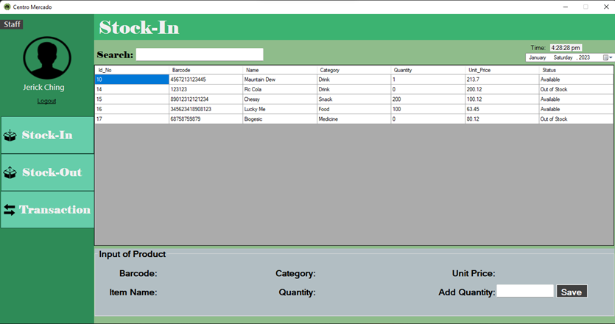

*Figure 8 Staff Stock-In Module*

This is Stock-In module where the staff inputs the new product/item for inventory records.



*Figure 9 Stock-Out Module*

This is the module where the staff enters the already sold products or items.



*Figure 10 Staff Transaction Record*

This module is where the staff can view the transaction records created by the admin.

**Appendix C: Curriculum Vitae**









